République Algérienne Démocratique et Populaire
Ministère de l'Enseignement Supérieur et de la Recherche Scientifique
Université des Sciences et de la Technologie Houari Boumediene


Advanced Programming
TP Project
Work represented to: SAOUDI Hadi

Presneted by :
- Bouasria Chaima
- Ameziane Manel Fatma
Group : 4
Matriculation IDs :
— 232333277216
— 232333151813

February 2026
TABLE OF CONTENTS
- Introduction
- Project Architecture Overview
- Database
- Core Features
4.1 Registration & Login System
4.2 Dashboard – Main User Interface
4.3 File Upload – Secure File Processing
4.4 File Download – Secure Retrieval System
4.5 File Deletion – Secure Removal System
4.6 Account Edit – Profile Management System
- File Sharing System
5.1 File Sharing Route
5.2 Shared File Access Route
- Collaborations & Team Workspaces
6.1 Team Workspace Overview
6.2 Collaborative File Management System
- Collaboration Invitation & Management
7.1 Collaboration Invitation System
7.2 Invitation Management System
- Collaborative Member & Folder Management
8.1 Collaborative Member Removal System
8.2 Collaborative Folder Deletion System
8.3 Collaboration Exit System
- Conclusion

Introduction:
SecureShare is a comprehensive web application designed to address the growing need for secure file storage and sharing in today's digital landscape. This platform combines end-to-end encryption with collaborative features, allowing users to store, share, and manage files while maintaining complete control over their data security.
Built with Flask and SQLAlchemy, the application implements military-grade AES-128 encryption to protect files both in transit and at rest. Users can manage personal files in a private encrypted vault, share individual files via time-limited access codes, and collaborate with teams through role-based shared folders.
Project Architecture Overview:
Backend Structure:
The system uses Flask with SQLAlchemy ORM and SQLite database. The backend handles authentication, file processing, and collaboration logic through dedicated modules. Flask-Login manages user sessions, while custom encryption modules provide end-to-end file security.
Security Architecture:
A multi-layered security model protects data throughout its lifecycle. User passwords are hashed with bcrypt, while files are encrypted using AES-128-CBC with unique salts per file. The system implements different encryption strategies: personal files use the owner's password, collaborative files use the folder creator's password.
Data Model Design:
The database features three interconnected systems: user management (Account), dual file storage (UploadedFile for personal, CollabFile for collaborative), and team collaboration (CollabFolder with role-based permissions). Foreign key relationships ensure data integrity across features.
Frontend Implementation:
Server-side Jinja2 templates create a responsive interface with consistent navigation. The UI follows component-based design with reusable elements like file cards and action buttons.
Feature Integration
The architecture enables seamless interaction between personal and collaborative features. Users can manage private files, share via time-limited codes, and participate in team workspaces—all within a unified security framework and consistent user experience.

Database:
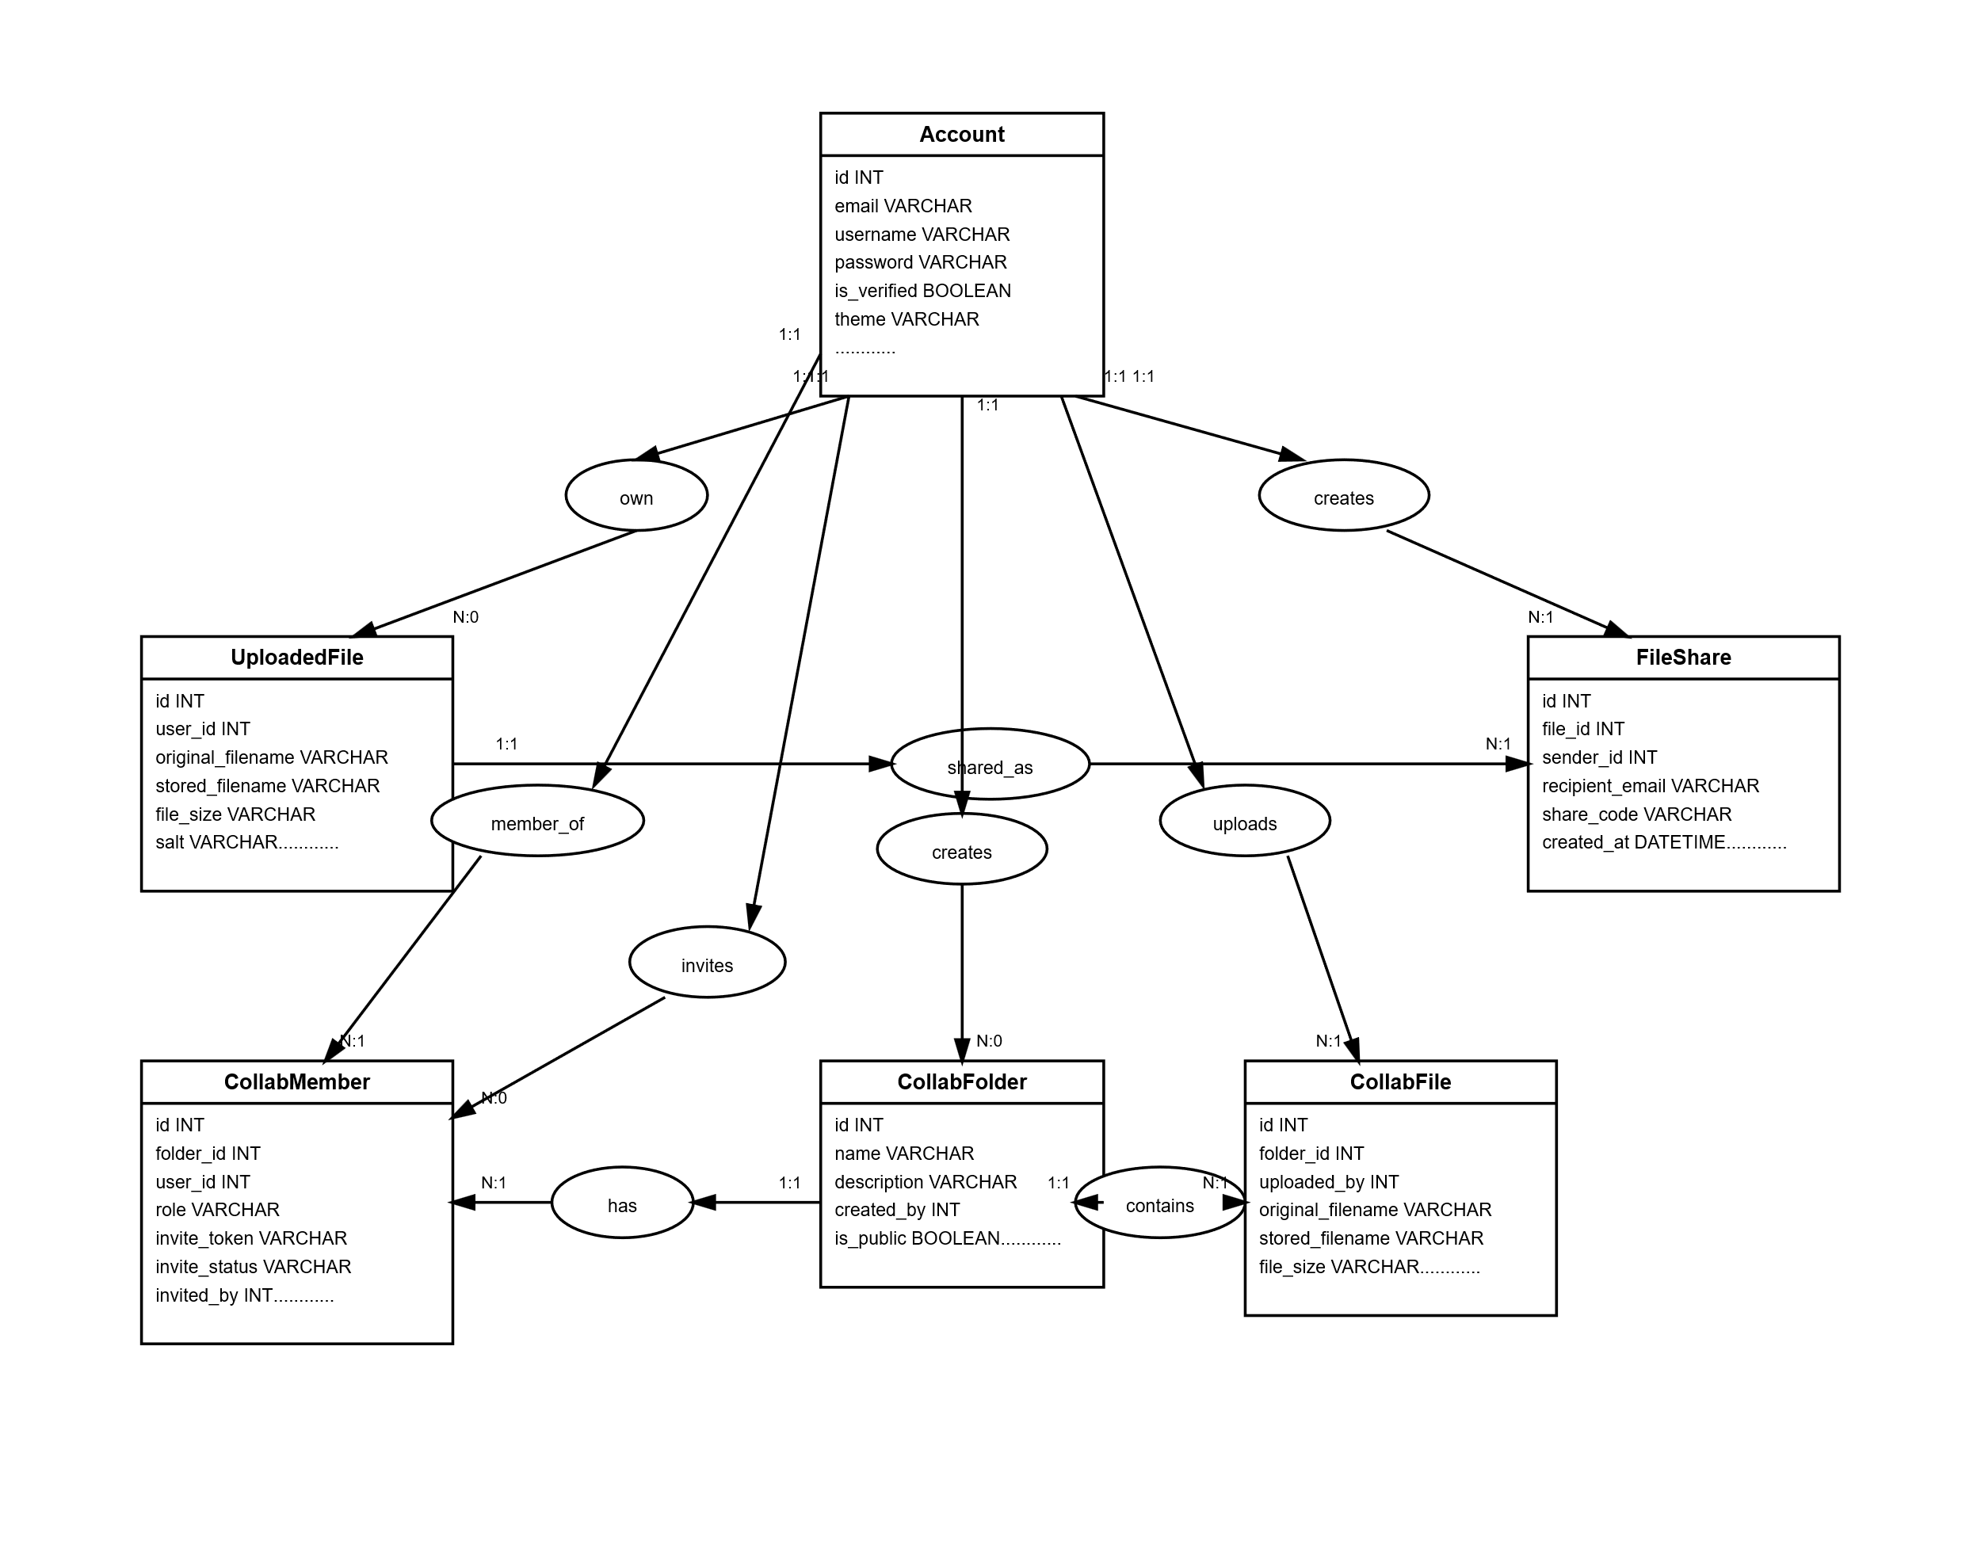

Tables:
Account:
- User authentication and profile management
- Central entity linking all user activities
UploadFile:
- Secure storage of user's personal files
- Encrypted file storage with individual encryption keys
FileShare:
- Time-limited, access-controlled file sharing
- No recipient account required - share via email

CollabFolder :
- Collaborative spaces for teams
- Shared file repository with access controls
CollabMember
- Controls who can access each folder
- Manages permission levels per user per folder
CollabFile
- Files within collaborative folders
- Separate from personal files for clear ownership

Core Features:
Registration & Login System
Registration Process
The registration system follows a secure three-step verification process. First, users submit a username, email address, and password. These credentials are validated to ensure uniqueness (for username and email) and password strength.
Once validation succeeds, the system generates a unique 6-digit verification code, stores it with a 15-minute expiration period, and sends it to the user via email.
After registration, users are redirected to a verification page where they must enter the code received. The account remains inactive until the correct code is submitted within the allowed timeframe. This approach enhances security while maintaining usability by preventing unauthorized access and allowing a reasonable verification window.
Verification Code Resend System:
The resend mechanism first verifies that the account exists and has not already been confirmed. It then generates a new verification code, updates the database with the new code and expiration time, and sends a new email to the user.
Login Authentication
The login system integrates Flask-Login for session management and bcrypt for secure password verification. User credentials are validated against bcrypt-hashed passwords stored in the database.
Before granting access, the system verifies that the user’s email address has been confirmed. A "Remember Me" option enables persistent sessions using secure cookies.

Logout System:
The logout process performs three key actions:
- Terminates the active session using Flask-Login’s logout_user() function
- Displays a confirmation message to the user
- Redirects the user to the login page for potential re-authentication
Email Integration
The system uses Flask-Mail with Gmail SMTP to send verification codes and notifications. The email module supports code regeneration with updated expiration times.
Email verification helps prevent spam accounts and ensures valid communication channels with users.
Dashboard - Main User Interface:
This route functions as the primary dashboard for authenticated users. It centralizes file management operations, presents user-specific statistics, and implements filtering mechanisms to support efficient file organization and navigation.
The route implements two-layer access control:
- Authentication requirement via @login_required decorator
- Email verification check that redirects unverified users to complete verification
This ensures only fully validated users can access the dashboard's features.
File Retrieval and Filtering System
The system implements a flexible query mechanism with dual filtering options:
- Favorite filtering: Isolates starred files for quick access
- Category filtering: Groups files by type (images, documents, videos, etc.)
Files are automatically sorted by upload date (newest first), providing chronological organization of user content.
Statistical Analytics
The dashboard computes and displays real-time usage statistics:
- Total file count: Current number of uploaded files
- Total downloads: Aggregate download activity across all files
- Favorite count: Number of files marked as favorites
Security Integration
By accessing current_user properties and filtering files by user_id, the route ensures data isolation between users. Each user sees only their own files and statistics, maintaining privacy and security within the multi-user environment.
This dashboard route represents the central hub of user interaction, combining security, functionality, and usability in a single cohesive interface that supports efficient file management and user engagement tracking.

File Upload - Secure File Processing
This route handles the secure file upload process, implementing end-to-end encryption and comprehensive validation before storing user files. It serves as the entry point for users to add new files to their encrypted storage vault.
Validation and Security Process
Before processing any upload, the system performs several validation checks, including file presence verification, filename validation, size enforcement (maximum 16MB), and authentication confirmation.
Encryption and Storage Workflow
Once validated, the file undergoes secure processing:
- SHA-256 hash generation for integrity verification
- AES-128-CBC encryption using a key derived from the user’s password
- Unique filename generation (user ID + timestamp + original name)
- Secure storage of encrypted data and decryption metadata
Security Architecture
The design follows a security-first approach:
- No plaintext files are stored
- Unique salts are generated per file
- Encryption keys are derived using PBKDF2
- File integrity is maintained through cryptographic hashing
File Download – Secure Retrieval System
This route manages secure file downloads by enforcing access control, performing decryption, and verifying file integrity. It enables users to safely retrieve their encrypted files from storage.
Access Control
Strict authorization checks are performed before processing:
- File existence verification (get_or_404)
- Ownership validation (file owner must match the current user)
- Authentication requirement for all download requests
Decryption and Integrity Workflow
The secure retrieval process includes:
- Encrypted file retrieval from storage
- Salt decoding from base64 format
- AES-128-CBC decryption using a password-derived key
- SHA-256 hash verification to detect tampering
- Temporary file generation for browser delivery
Security Features
- Decryption occurs only at the time of authorized download
- Integrity checks detect corruption or modification
- Plaintext files are stored temporarily and removed after delivery
- Download counters track usage for auditing
File Deletion Route – Secure Removal System
This route manages secure file deletion by removing both the encrypted file from storage and its associated database records. It ensures complete cleanup while maintaining data integrity and security.
Access Control and Validation
Before deletion, the system performs strict checks:
- File existence verification
- Ownership confirmation (users can delete only their own files)
- Authentication enforcement via login requirement
- POST-only access to prevent accidental browser-triggered deletions
Dual Deletion Process
Deletion follows a two-phase strategy:
- Removal of the encrypted file from server storage
- Deletion of related database records
Security and Design Considerations
- Complete removal of encrypted data from storage
- Ownership verification before destructive actions
- All-or-nothing deletion to preserve consistency
- Secure handling of destructive operations via POST requests
Account Edit Route – Profile Management System
This route allows authenticated users to securely update their profile information, including username, email, and password. It provides a controlled interface for self-service account management.
Access Control
Strict authorization measures are enforced:
- Authentication requirement for all access
- Account existence verification
- Ownership validation (users may edit only their own account)
Profile Update Workflow
The route supports both request methods:
- GET: Displays a pre-populated form with current account data
- POST: Processes submitted updates with validation and security checks
Password updates are optional. When provided, passwords are securely hashed using industry-standard algorithms (e.g., bcrypt) before storage.
Session Management
After successful updates—especially password changes—the system:
- Invalidates the current session
- Re-authenticates the user with updated credentials
- Prevents caching issues through timestamp-based cache control
Security Considerations
- Prevention of cross-user account modification
- Secure password hashing
- Session invalidation after credential updates
- Input validation through controlled form processing
File Sharing System
File Sharing Route
This route allows users to securely share their files with external recipients through email-based access codes. Recipients can download files without creating an account, while access remains controlled and time-limited.
Access Control
The system ensures:
- File existence verification (get_or_404)
- Ownership validation (users can share only their own files)
- Authentication requirement
- Input validation for recipient email and sharing parameters
Share Configuration
Users can configure:
- Recipient email
- Download limit (default: 5)
- Expiration period (default: 7 days)
- Auto-generated 8-character access code
Shared File Access Route
Public Access Interface
This route enables code-based file retrieval without authentication. Recipients enter the access code to download the shared file.
Validation Process
Before granting access, the system verifies:
- Code existence and validity
- Share status and expiration
- Download usage limits
- Case-normalized code matching
Secure Retrieval Workflow
If validation succeeds:
- Usage counter increments
- Encrypted file is retrieved
- Decryption is performed using the file owner’s credentials
- SHA-256 integrity verification is executed
- A temporary file is generated for secure browser delivery
Security Architecture
The sharing system enforces:
- Dual restrictions (time-based + usage-based limits)
- Unique access codes preventing guessing attacks
- Silent integrity monitoring
- Temporary plaintext handling (no persistent decrypted storage)
- Owner-based decryption maintaining key isolation
System Integration
The sharing feature integrates with:
- Email delivery for access notifications
- Database relationships linking files, shares, and senders
- Encryption infrastructure for secure decryption
- Usage tracking for monitoring and auditing
Collaborations – Team Workspace Overview
This route serves as the central hub for collaborative workspaces, displaying all folders where the authenticated user holds membership. It acts as the entry point for team-based file management.
Access Control and Data Retrieval
Access is restricted to logged-in users. The system retrieves only folders where the current user has an active membership role, ensuring strict data isolation.
Folder data is obtained through membership relationships, with user context included for personalized interface rendering.
Security Implementation
Security is enforced through:
- Query-level filtering by user_id
- Database relationship integrity via foreign keys
- Authentication as the primary access requirement
Collaborative File Management System
Folder Creation
Workspace Establishment
Users can create collaborative workspaces by submitting a folder name, description, and visibility settings. The system validates inputs, creates the folder entity, and automatically assigns the creator as the owner with administrative privileges.

Folder View
Contextual Display
The folder view aggregates:
- Folder metadata
- Files sorted chronologically
- Member lists with assigned roles
- The current user’s permissions
Access Control
Access is validated through a centralized user_has_folder_access function, ensuring only members can view folder contents and preventing unauthorized exposure.

Collaborative File Upload
Permission-Based Submission
File uploads require editor-level permissions or higher, restricting content submission to authorized members.
Shared Encryption Model
Files within a folder use a unified encryption key derived from the creator’s password. This allows authorized members to access shared files while maintaining encrypted storage. Upload attribution and automatic categorization are also recorded.
Collaborative File Download
Membership Validation
Download requests verify folder membership before retrieval, enforcing workspace boundaries.
Creator-Based Decryption
Decryption uses the folder creator’s password-derived key, enabling seamless access for all authorized members under a shared encryption model.
Integrity Verification
SHA-256 hashes are silently compared during download to detect corruption or tampering. Integrity issues are logged without disrupting user experience.
Security Architecture
Role-Based Permissions
The system defines hierarchical roles:
- Viewer: Read-only access
- Editor: Upload capabilities
- Owner: Full administrative control
System Integration
The collaborative module extends the core file management system by reusing encryption, storage, and integrity mechanisms while adapting them for multi-user contexts.
Collaboration Invitation System
This route manages invitations to collaborative folders, allowing folder owners to invite registered users with specific permission levels. It creates secure invitation records and sends email notifications to prospective members.
Access Control
The system enforces strict authorization rules:
- Owner-only permission for sending invitations
- Folder existence verification
- Authentication requirement
- Validation of required invitation parameters
Invitation Validation
Before creating an invitation, the system verifies:
- The invited email belongs to a registered user
- No existing membership or pending invitation already exists
- The assigned role is valid
- Appropriate feedback is provided based on membership or invitation status
Secure Invitation Mechanism
Invitations use a token-based security model:
- Cryptographically secure unique token generation
- Invitation record creation with status tracking
- 7-day expiration period
- Inviter attribution for audit purposes
Email Integration and User Experience
Invitations are delivered through:
- Direct acceptance links (no manual code entry required)
- HTML-formatted emails with folder and inviter details
- One-click acceptance or decline actions
Security Architecture
The system ensures:
- Token-based protection against forgery
- User verification before invitation issuance
- Role-based permission enforcement
- Status tracking to prevent reuse or replay attacks
System Integration
The invitation route integrates with:
- User authentication and permission systems
- Email delivery infrastructure
- Database relationship models
- URL routing for secure invitation links
Invitation Management System
Invitation Viewing Route
Validation Process
Before displaying invitation data, the system verifies:
- Token validity (invitation exists)
- Invitation status (must be pending)
- Expiration window (7-day validity)
- Folder and inviter context for informed decision-making
Only valid, unexpired invitations are displayed.
Invitation Acceptance Route
User Verification
Acceptance requires:
- User authentication
- Ownership confirmation (invitation must match the logged-in user)
- Status validation (invitation still pending)
If the user is not logged in, the token is temporarily stored in session to preserve context during authentication.
Acceptance Processing
Upon successful validation:
- Invitation status changes from pending to accepted
- Token is invalidated (one-time use)
- Acceptance timestamp is recorded
- Database transaction commits membership creation
Users are then redirected to the collaborations interface with immediate folder access.
Invitation Declination Route
Parallel Security Model
Declination follows the same validation steps:
- Token verification
- Authentication handling
- Ownership confirmation
- Status validation
Declination Processing
When declined:
- Status updates to rejected
- Token remains stored (for record tracking)
- Decision is logged for audit purposes
No membership is created, and the folder remains unaffected.
Security Architecture
Token-Based Security
- Cryptographically secure invitation tokens
- One-time-use tokens for acceptance
- 7-day expiration enforcement
- Token binding to specific user accounts
State Management
- Strict status validation prevents reprocessing
- Atomic database transactions
- Rollback capability on failure
Informed Decision Interface
The invitation page displays:
- Folder details
- Inviter identity
- Clear accept/decline options
- Current invitation status
Seamless Authentication Flow
- Token preservation during login
- Automatic return to invitation context
- Smooth redirection after processing
System Integration
The invitation system integrates with:
- User authentication and session management
- Folder and membership database relationships
- Email notification infrastructure
- Collaboration dashboard for post-acceptance access

Collaborative Member Removal System
This route allows folder owners to remove members from collaborative workspaces, ensuring controlled team management while preserving folder integrity.
Access Control
Member removal is restricted through strict authorization rules:
- Owner-only permission for removal actions
- Authentication requirement
- Self-removal prevention for owners
- Multi-owner protection to prevent accidental loss of all administrators
Validation and Safety Checks
Before removal, the system verifies:
- Member existence (get_or_404)
- Proper ownership authority of the requesting user
- Protection against removing other owners when it would compromise administrative continuity
Removal Process
The operation involves:
- Direct deletion of the member record from the CollabMember table
- Automatic cascade handling through database relationships
- Immediate revocation of all folder permissions for the removed user
Security Considerations
- Ownership hierarchy preservation
- POST-only access to prevent accidental deletions
- Referential integrity maintained through database constraints
- Session-based authorization for all removal requests
Collaborative Folder Deletion System
This route enables folder owners to permanently delete collaborative workspaces, including all associated files and memberships, while preserving data integrity and security.
Access Control
Deletion is strictly restricted through:
- Owner-only permissions
- Authentication requirement
- Folder existence verification (get_or_404)
- Explicit ownership validation before execution
Comprehensive Cleanup Process
Folder deletion includes:
- Retrieval of all associated files
- Physical removal of encrypted files from server storage
- Cascade deletion of folder records and related memberships
- Automatic cleanup of dependent relationships through database constraints.
Security Considerations
- Permission-based deletion control
- POST-only access to reduce accidental actions
- Transaction rollback on failure
- Strict ownership enforcement
Collaboration Exit System
This route allows users to voluntarily leave collaborative folders while preserving workspace integrity. It provides a self-service exit mechanism with safeguards to prevent administrative abandonment.
Access and Validation
Before processing an exit request, the system verifies:
- Folder existence
- Current user membership
- Authentication status
- POST-only access to prevent accidental exits
Users may remove only themselves from a folder.
Critical Safety Mechanism
The system prevents the last remaining owner from leaving a folder.
If the exiting user holds an owner role, the system:
- Counts the total number of owners
- Enforces a minimum requirement of at least one remaining owner
- Blocks the exit if it would leave the folder without administrative oversight
In such cases, users are advised to transfer ownership or delete the folder instead.
Exit Process
If validation passes, the system:
- Deletes the user’s membership record
- Immediately revokes all folder permissions
- Preserves folder data and other member relationships
The exit affects only the departing user.
Security and Integrity
- Administrative continuity is maintained
- Role-based permission boundaries are enforced
- Other members’ access and data remain unaffected
- Database operations use transaction control for consistency
Conclusion
Project Overview
SecureShare delivers a secure file storage and collaboration platform that combines strong security mechanisms with user-friendly functionality. Supporting both personal file management and team collaboration, the system implements end-to-end encryption, role-based access control, and secure sharing workflows. Built with Flask and SQLAlchemy, its modular architecture ensures data integrity while handling complex user interactions.
Key Achievements
The project integrates layered security, including AES-128-CBC encryption with unique salts, SHA-256 integrity verification, and PBKDF2 key derivation. It also implements structured permission roles within collaborative workspaces while maintaining encryption consistency.

